Assignment 2 Report

Student Name: Wei Tang

Student ID: 29504449

Tutor Name: Jeffery Liu

Word Count: 998 words

Visualisation URL:

# Description

The field of interest is the COVID-19 situation all over the world and the detailed summary in Australia. The aim is to find the overview COVID-19 situations in different continents and also the details of the condition in Australia to date.

The covid-19 has always been a popular topic of concern, as the number of cases and deaths continued to rise, people are beginning to pay attention to this human-to-human transmission. Therefore, the action is to discover and present for the people who care about the global COVID-19 situation and the deaths/recovered rate trends.

# What

The dataset contains about the COVID-19 detailed changing situation from the worldwide which is authored by Devakumar kp. It contains the COVID-19 attributes such as active, recovered and deaths, etc and the region. The purpose of this dataset is according to the changes of the attributes which are mentioned above, to discover if the existing vaccines or treatments are effective and also the transmission rate or infection rate in different regions. However, in this visualisation, we only focus on the case changes in different countries and the overview situation all over the world and also the attribute change trend of different regions in the period of time.

**The choropleth map:** this visualisation shows the total cases in the worldwide. The colour luminance represents the severity of infection in a country’s population (the quantitative data: TotalCases).

**The multiple-view line chart:** this visualisation shows the trends in the number of deaths from COVID-19 across continents overtime. The x-axis is the date which represents the categorical data and the y-axis is the deaths cases which represents the quantitative data.

**The bar chart:** this visualisation shows the top-10 countries deaths cases due to COVID-19. The x-axis is the number of the death cases which represents the quantitative data and the y-axis is the country name which represents the categorical data.

**The bubble chart:** this visualisation shows the relationship between deaths cases and confirmed case. The x-axis is the number of confirmed cases and y-axis is the number of deaths cases which represent the quantitative data.

**The pie chart:** this visualisation shows the details of deaths, active and recovered cases of COVID-19 of different regions in Australia. The quantitative attributes are the number of death cases, active cases and recovered cases. The categorical attribute is the regions in Australia.

# Why & How

#

**(Figure. 1)**

**The choropleth map:** the mark is geographic regions and the colour luminance channel is used for quantitative attribute which is the total case of COVID-19. The darker the colour, the more cases there are in that region. The target is to get a directly view of COVID-19 in varies countries around the word.

**The multiple-view line chart:** the mark for this visualisation is line. The colour hue is used for the categorical data which are deaths, active and confirm. This visualisation combines the four attributes to represent different trends of COVID-19. The multi-view line chart presents the different of trends and numbers regards four attributes from the dataset in one visualisation so that the reader can realise how the number of deaths related to the active cases, confirmed cases and recovered cases.

**The bar chart:** line is the mark which is used for this visualisation. The vertical position scale channel is used for categorical attribute which is the country name and the horizontal position scale channel is used for quantitative attribute which represents the number of the death cases. The colour luminance also used in this visualisation that is the darker the colour, the more cases the country has. The bar chart sorted the countries and colour luminance by difference of death cases number with a mean death number line to give a clearly data overview.

**The bubble chart:** the mark is circle and both vertical and horizontal position channel are used for the quantitative attribute which are total death cases and the total confirmed cases. The colour channel is used for the categorical attribute which represents the continents and the size of circle represents the quantitative attribute which represents the number of the population. The aim is to show the relationships among those attributes.

**The pie chart:** the mark is area and the colour hue represents the categorical data which represents different province in Australia. The hconcat usage to show three different attributes, and the highlight click is used for reader to discover the number difference of three attributes for one region. Through the pie chart, the reader can institutively discover the number distribution regards three attributes in different Australia regions.

**#**

**(Figure. 2)**

# Design

Layout

Let the reader read from heading and then top to bottom, left to right. The whole layout can be divided into four parts: heading with introduction, the first part, middle part and bottom part. The visual centre is consistent as for each part the centre is the diagram. Furthermore, use the white space to make sure the page looks tidy and let the reader read through easier.

Colour

The colour used in this visualisation is white, black and red. The white is the background colour and the black colour is used for the text font. I chose red for the overall visualisation because red is more visually indicative of severity of COVID-19. The red colour and its luminance represent the **quantitative data** and the black colour represent the **categorical data**.

Figure-ground

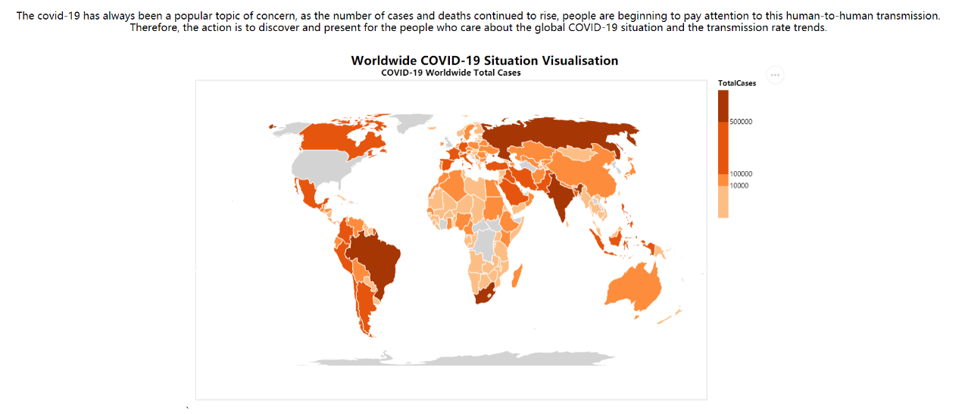

**(Figure.3)**

Increase the size of the main chart (as figure.3 shown) and use the title /subtitle to divide the visualisation. Meanwhile, the elements appear symmetrically on the page. As Figure.1 shown, the whole visualisation is divided into three rows and for each diagram in the row, it has its own descriptions.

Typography

The reason is that the Sego UI is attractive and easy to read. The heading has large font size and the title for each diagram has larger and bold font size than text as well. Moreover, the important information is highlighted by using bold which make the info more prominent.

Storytelling

The top text under the title gives a brief description for charts. When reader follow the structure read through (top to bottom, left to right), each chart has an introduction under the subtitle to guide the reader and describe the chart briefly.

# References

<https://www.kaggle.com/imdevskp/corona-virus-report>

# Appendix

# 

